Housing Price Prediction Model for D.M. Pan Real Estate Company
[Your Name]
Southern New Hampshire University

Module Two Notes
[Copy and paste any relevant information from your Module Two assignment here to assist you in completing this assignment. This section is not graded and is only provided to help you easily review Module Two assignment information while completing this assignment.]

Regression Equation
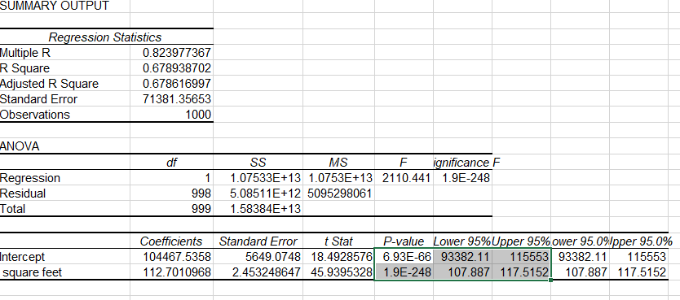
Median listing price (y)=104467.53+112.70(x) median square feet

Determine r
The correlation coefficient is positive 0.8240
The correlation coefficient (r) measures the relationship between the two variables
There is a positive linear relationship between the median listing price and the median square feet.
There is a strong correlation because the coefficient is 0.8240.
The direction of the variable is determined by the correlation value. If it is positive then it moves upwards and if negative it moves downwards. So here it moves upwards

Examine the Slope and Intercepts

Slope is 112.70 and intercept= 104467.54
Interpretation:
Slope =112.70 :the average median listing price increases 112,70 with unit change in median square feet
Intercept =104467.54: there is only physical interpretation when median square feet is zero
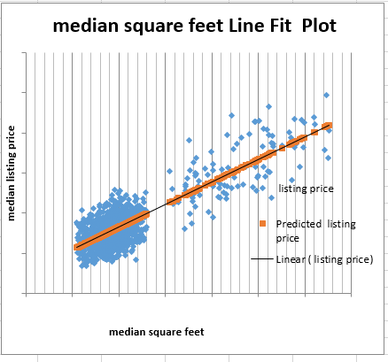

R-squared Coefficient
The value of R-squared is 0.67893 that is the model explains only 67.89% variability in median listing price due to median square feet. The value of R-squared is large and therefore the model is goodfit.
Land value is obtained by putting x=0 in the fitted line
Land value =104467.54
Average median listing price is 104467.54 when the median square feet is zero

Conclusions
From minitab and using the selected region as East North central with 100 observations and comparing it with the overall US data having 1000 observations.
Output: P=<0.0001 we reject the null hypothesis and therefore significantly different.
That is, square feet is different for selected regions and overall US data.

Given the value square feet =100
Y=104467.53+112.70X
Median listing price=104467.53+112.70*100=115737.53
For every 100 square feet the price rises by 112.70*100=11270
for square feet =1200
median listing price= 104467.53+112.70*1200= 239707.53

